

Green University Of Bangladesh
Department Of Computer Science & Engineering

Project Report For Intelligent smart home automation using Arduino simulator

Afsana Kabir Sinthia
ID:182002068
Razia Sultana Urmi
ID:182002079
Md Sofiullah Asrafi
ID:182002122

Supervisor: Md. Parvez Hossain
Lecturer
Dept. Of CSE
Department of Computer Science
Green University Of Bangladesh

Smart Home

Table of Contents
Abstract 3
Project Specification 4
Chapter 1: Introduction 5
1.1 Motivation 5
1.2 Objective 5
Chapter 2: Design Method 6
Chapter 3: Tools 8
Chapter 4: Procedure 9
4.1 Steps 9
Chapter 5: Result Analysis 9
5.1 Figures, Charts and Tables 9
5.2 Output 9
Chapter 6: Difficulties 11
Chapter 7: Problems 12
Chapter 8: Discussion 14
Chapter 9: Futurework 14
Chapter 10: References 15

Abstract
We are living in 21st century where automation of any form i.e. home or industrial plays an important role in human life. When it comes to industrial automation, the concept is applied to large machines or robots which help in increasing the efficiency in terms of production, energy and time. Home automation on the other hand involves automating the household environment. This is possible because of the smartphones and internet that we are widely using. Home automation can be again divided in to just controlling the appliances using a smartphone from a remote location and another type filled with sensors and actuators which controls the lighting, temperature, door locks, electronic gadgets, electrical appliances etc. using a “Smart” system. The main objective of this project is to develop a home automation system using an Arduino board with Bluetooth being remotely controlled by any Android OS smart phone. As technology is advancing so houses are also getting smarter. Modern houses are gradually shifting from conventional switches to centralized control system, involving remote controlled switches. Presently, conventional wall switches located in different parts of the house makes it difficult for the user to go near them to operate. Even more it becomes more difficult for the elderly or physically handicapped people to do so. Remote controlled home automation system provides a most modern solution with smart phones. In order to achieve this, a Bluetooth module is interfaced to the Arduino board at the receiver end while on the transmitter end, a GUI application on the cell phone sends ON/OFF commands to the receiver where loads are connected. By touching the specified location on the GUI, the loads can be turned ON/OFF remotely through this technology. The loads are operated by Arduino board through up to - isolators and thyristors using triacs.

Project Specification
Project Aim The aim of the project is to design and construct a home automation system that will remotely switch on or off any household appliances connected to it, using a microcontroller, voice dial on phone, or Bluetooth based android application. Project Objective The objective of this project is to implement a low cost, reliable and scalable home automation system that can be used to remotely switch on or off any household appliance, using a microcontroller to achieve hardware simplicity, low cost short messaging service for feedback and voice dial from any phone to toggle the switch state.

Introduction
Voice controlled Home Automation using Arduino:
In this project, we are using a voice function to control home devices. This project is the part of my Home Automation series. This project is similar to home automation using Bluetooth. In that project we use the S2 Terminal application in this we use AMR Voice application. This application is free and very easy to use. This project is very easy to use in real life. People of any age can control it by just speaking the commands. This Arduino based project has a larger range than IR and PC-based ones. Before making this project, you should know how to interface HC 05 Bluetooth module with Arduino and should also know about Arduino programming basics.
1.1 Objective
- Project Objective The objective of this project is to implement a low cost, reliable and scalable home automation system that can be used to remotely switch on or off any household appliance, using a microcontroller to achieve hardware simplicity, low cost short messaging service for feedback and voice dial from any phone to toggle the switch stateTo allow the customer to make order, view order and make changes before submitting their order and allow them make payment through prepayment card or credit card or debit card.
1.2 Motivation
1.Our firm interest in working for the people with the special needs (disabilities). Our project implementation could cause a big change in the way of using facilities, which normally would have been difficult or maybe impossible at a certain level. The ease of using facility is now just waiting for the voice order to perform the action.

Design Method
In this phase, logic system is built which fulfils the given requirements. Design phase of software development deals with transforming the requirements.
App Design:
- Mit A2 inventor.

Backend Design:
Design 1:Home.

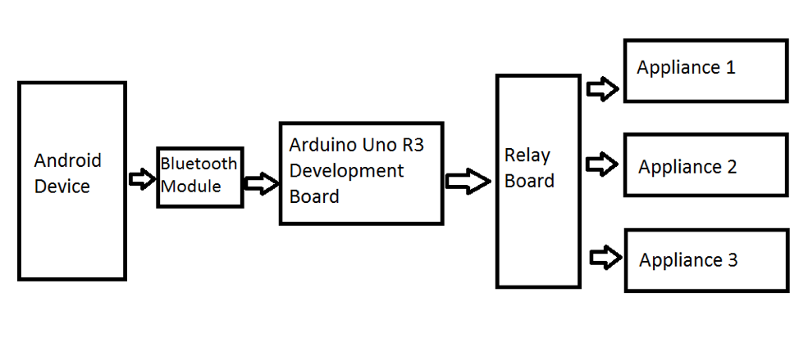

- Project Method design.

Tools
For the effective implementation of the new system, the following software has to be installed on the computer
- Windows Xp, Windows 7,10 or Vista
- Proteus 8
- Arduino simulator
- MIT A2 Invantor
- Bluetooth enabled smartohone

Procedure
The application is built in a modular form where these functionalities are built into modules. Some of the modules are as follows.

Steps

Proteus Part:
- Create circuit .
- Add motor as a fan(two motor in this project).
- Add lamp for light.
- Add LED-YELLOW (for night light).
- Bluetooth HC-05.
- Reay (switch).
- Diode and 2n222 for connection .
- Arduino uno r3.
- Register (1kohm for each) and dc 12v.

Mit a2 app :
- Create mit app from http://ai2.appinventor.mit.edu/#6336504176967680 .
- Coding in Arduino software .
- Commands :
1.light on
2.light off
3.fan off
4.fan on
5.night lamp on
6.night lamp off
7.all off and all off

Result Analysis

Figures
15 Analog Pins A0 – A5 Used to provide analog input in the range of 0-5V Input/output Pins Digital Pins 0 – 13 Can be used as input or output pins. Serial 0(Rx), 1(TX) Used to receive and transmit TTL serial data. External Interrupts 2 2, 3 To trigger an interrupt. PWM 3, 5, 6, 9, 11 Provides 8-bit PWM output. SPI 10 (SS), 11 (MOSI), 12 (MISO) and 13 (SCK) Used for SPI communication. Inbuilt LED 13 To turn on the inbuilt LED. TWI A4 (SDA), A5 (SCA) Used for TWI communication AREF AREF To provide reference voltage for input voltage. Communication Arduino can be used to communicate with a computer, another Arduino board or other microcontrollers. The ATmega328P microcontroller provides UART TTL (5V) serial communication which can be done using digital pin 0 (Rx) and digital pin 1 (TX). There are two RX and TX LEDs on the Arduino board which will flash when data is being transmitted via the USB-to-serial chip and USB connection to the computer (not for serial communication on pins 0 and 1). A Software Serial library allows for serial communication on any of the Uno's digital pins.
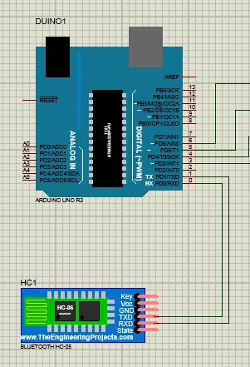.

Output

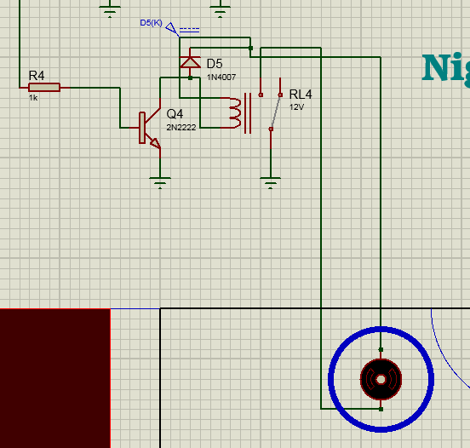

Night light:
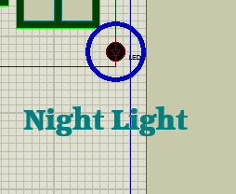

Fan :
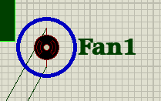
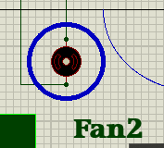

Light:
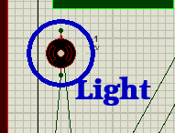

Full project:
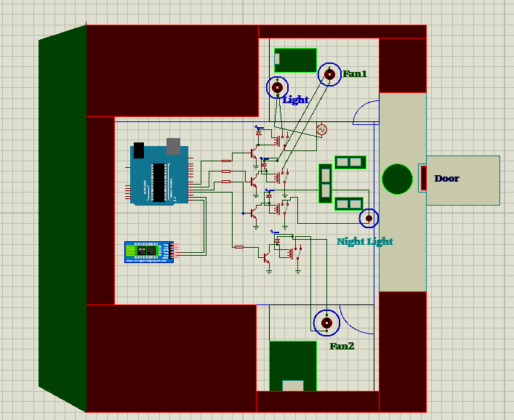

App:
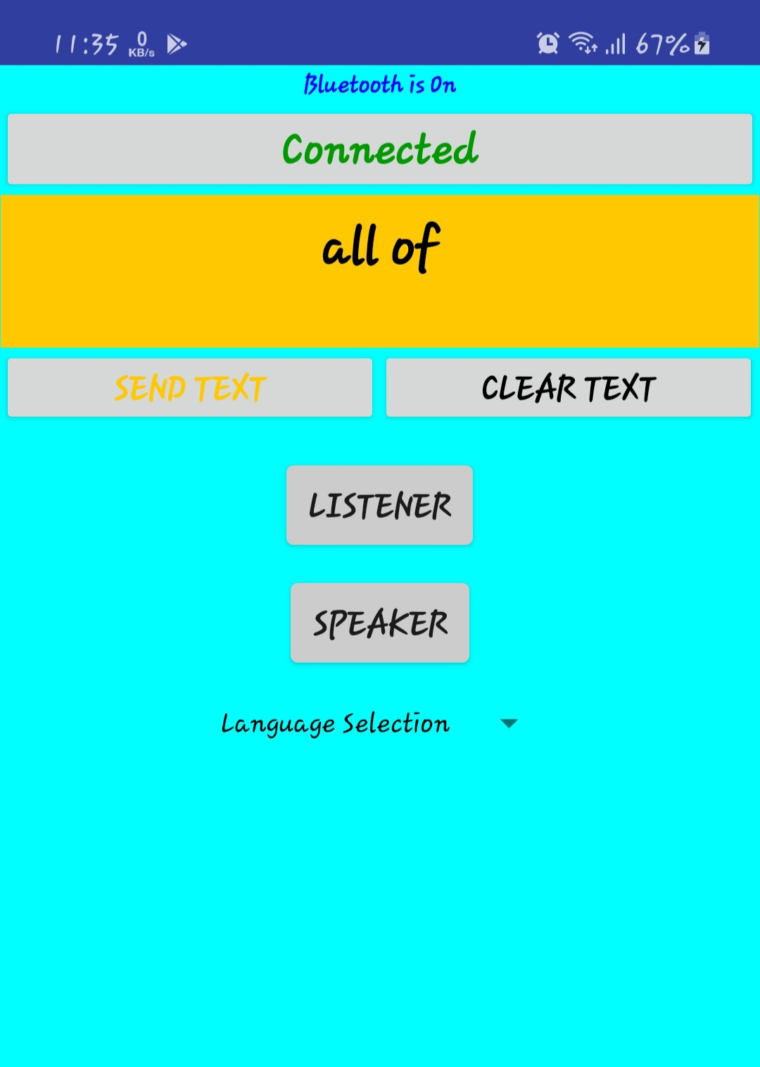

Source code:

String voice;
void setup() {
Serial.begin(9600);
pinMode(6, OUTPUT);
pinMode(5, OUTPUT);
pinMode(4, OUTPUT);
pinMode(3, OUTPUT);
}

void loop() {
while(Serial.available()){
delay(3);
char c = Serial.read();
voice+=c;}

if(voice.length() >0){
Serial.println(voice);
if(voice == "light on")
{digitalWrite(6, HIGH);}
else if(voice == "light off")
{digitalWrite(6, LOW);}
else if(voice == "fan on")
{digitalWrite(5, HIGH);
digitalWrite(3, HIGH);}
else if(voice == "fan off")
{digitalWrite(5, LOW);
digitalWrite(3, LOW);}
else if(voice == "night lamp on")
{digitalWrite(4, HIGH);}
else if(voice == "night lamp off")
{digitalWrite(4, LOW);}
else if(voice == "all on")
{digitalWrite(4, HIGH);
digitalWrite(5, HIGH);
digitalWrite(6, HIGH);
digitalWrite(3, HIGH);}
else if(voice == "all off")
{digitalWrite(4, LOW);
digitalWrite(5, LOW);
digitalWrite(6, LOW);
digitalWrite(3, LOW);}
voice = "";}
}

Difficulties
Difficult part is connecting Bluetooth to proteus.
1.As online project, we need to connect phone app.
2.We faced problem building the circuits as well as building the app also.
3.On the Other parts, source code must connect correctly.

Chapter 7: Problems
Due to online base project we could implement real life . Most of the problems include:
1. We didn’t add many features.
2. It is only Bluetooth base so Wi-Fi connection won’t be available.

Chapter 8: Discussion
The home automation system has been experimentally proven to work satisfactorily by connecting sample appliances to it and the appliances were successfully controlled from a wireless mobile device. We learned many skills such as soldering, wiring the circuit and other tools that we use for this project and was able to work together as a team during this project. The Bluetooth client was successfully tested on a multitude of different mobile phones from different manufacturers, thus proving its portability and wide compatibility. Thus a low-cost home automation system was successfully designed, implemented and tested.
Chapter 9: Future Work
1. Using this project, we can turn on or off appliances remotely i.e. using a phone or tablet. 2. The project can be further expanded to a smart home automation system by including some sensors like light sensors, temperature sensors, safety sensors etc. and automatically adjust different parameters like room lighting, air conditioning (room temperature), door locks etc. and transmit the information to our phone 3. Additionally, we can connect to internet and control the home from remote location over internet and also monitor the safety. Future Development of the project. 4. Arduino based device control using Bluetooth on Smartphone project can be enhanced to control the speed of the fan or volume of the buzzer etc. 5. Home automation and Device controlling can be done using Internet of Things – IOT technology. 6. We can replace Bluetooth by GSM modem so that we can achieve device controlling by sending SMS using GSM modem.

Chapter 10: References
https://www.researchgate.net/publication/340226739_VOICE_CONTROLLED_HOME_AUTOMATION
https://www.youtube.com/watch?v=cXbBIKU0j00

